**Practical – 1: Application of Regression Analysis in Data Analytics.**

**1) Linear Regression –**

**Description:** We download a dataset that is related to fuel consumption and Carbon dioxide emission of cars. Then, we split our data into training and test sets, create a model using training set, evaluate model using test set, and finally use model to predict unknown value.

**Code:**

import matplotlib.pyplot as plt

import pandas as pd

import pylab as pl

import numpy as np

**# data import**

df = pd.read_csv("data-genrator/FuelConsumptionCo2.csv")

cdf = df[['ENGINESIZE','CYLINDERS','FUELCONSUMPTION_COMB','CO2EMISSIONS']]

**# relation visuallization**

plt.scatter(cdf.ENGINESIZE, cdf.CO2EMISSIONS, color='blue')

plt.xlabel("Engine size")

plt.ylabel("Emission")

plt.show()

**# split data**

msk = np.random.rand(len(df)) < 0.8

train = cdf[msk]

test = cdf[~msk]

**# model fitting**

from sklearn import linear_model

regr = linear_model.LinearRegression()

train_x = np.asanyarray(train[['ENGINESIZE']])

train_y = np.asanyarray(train[['CO2EMISSIONS']])

regr.fit (train_x, train_y)

print ('Coefficients: ', regr.coef_)

print ('Intercept: ',regr.intercept_)

**# Plot regression line**

plt.scatter(train.ENGINESIZE, train.CO2EMISSIONS, color='blue')

plt.plot(train_x, regr.coef_[0][0]*train_x + regr.intercept_[0], '-r')

plt.xlabel("Engine size")

plt.ylabel("Emission")

**# r2 calculation**

from sklearn.metrics import r2_score

test_x = np.asanyarray(test[['ENGINESIZE']])

test_y = np.asanyarray(test[['CO2EMISSIONS']])

test_y_ = regr.predict(test_x)

print("Mean absolute error: %.2f" % np.mean(np.absolute(test_y_ - test_y)))

print("Residual sum of squares (MSE): %.2f" % np.mean((test_y_ - test_y) ** 2))

print("R2-score: %.2f" % r2_score(test_y_ , test_y) )

**Output:**

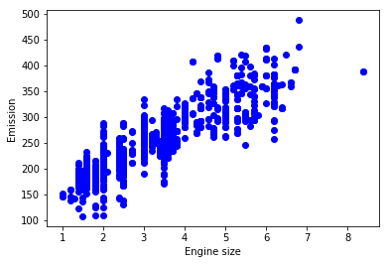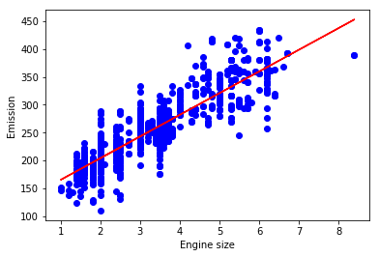

Coefficients: [[38.89929855]]

Intercept: [126.30857997]

Mean absolute error: 25.23

Residual sum of squares (MSE): 1090.08

R2-score: 0.64